Van Lang University

**Software Measurement and Analysis Course**

**VIKING’S PROJECT DASHBOARD**

**Version number:** 1.1

**Author:** K14T01 – Team 01

**Team member:**

Duong Nguyen

Mung Nguyen

Manh Nguyen

Binh Huynh

Hien Nguyen

**TABLE OF CONTENT**

Table of Contents

**1.** **INTRODUCTION :** 2

**2.** **MAIN OF STATUS REPORT :** 2

**2.1** **Summary Status :** 2

**2.2** **Mile Stone Status :** 3

**2.3** **EV Status :** 3

**2.4** **Resource Status :** 5

**2.5** **Defect & Change Request Status :** 5

**2.6** **Feature Status :** 6

**2.7** **Testing Status :** 7

**2.8** **Risk Status :** 8

**3.** **DASHBOARD :** 8

1. **INTRODUCTION :**

After each integration or milestone, or whenever that stakeholder need reported of Viking’s project done, project manager will report with Stakeholder about current project introduction. Dashboard is efficiency tool to support you. And then, Document will introduce and describe data collecting, chart that will present, meaning of them, and then approach to report with your directory.

1. **MAIN OF STATUS REPORT :**
   1. **Summary Status :**

We show status of project by using the chart or model display. Now, we can see example below.

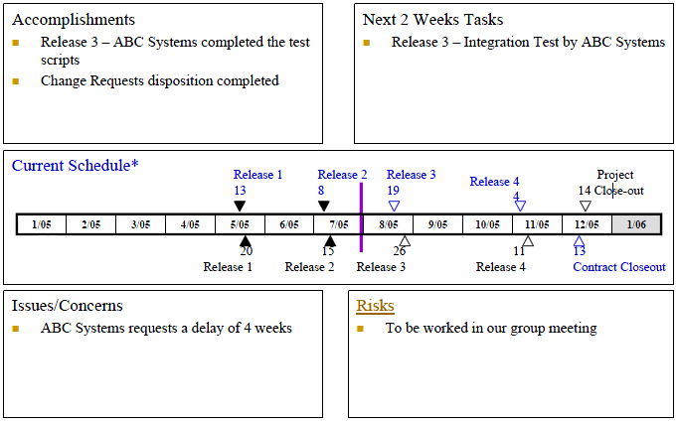

The Data will be collected is:

|  |  |  |  |
| --- | --- | --- | --- |
| **Data Collection** | **Purpose** | **Location** | **Periodic** |
| * Current Schedule:   Completed milestones  Customer milestones  ABC systems milestone  - Accomplishments  - Next 2 weeks tasks  - Issues/Concerns  - Risks | - Show general project  - Show last week’s accomplishment  - Create test scripts completed for next releases | MS project | Monthly |

* 1. **Mile Stone Status :**

Milestones reported with chart:

Data will be collected is Milestones and Time of Milestones in Plan. Besides, we get data about milestone that Actual acquired.

* 1. **EV Status :**

Using Earned Value to report:

Besides, we are using Bull eyes Chart to report:

So, Data will be collected is:

|  |  |  |  |  |
| --- | --- | --- | --- | --- |
| **Data Collection** | **Description** | **Location** | | **Periodic** |
| **BCWS** | Budgeted Cost of Work Scheduled. ... For a <Resource>, it is the rolled-up summary of a resource's BCWS values for all assigned tasks | MS Project | | Weekly |
| **BCWP** | Budgeted Cost for Work Performed; Earned Value; the dollar amount of work that was actually accomplished; [Budget] X [percent complete] | MS Project | | Weekly |
| **ACWP** | Actual Cost of Work Performed during a given time period; money spent up to the current date. ... Cost Performance Index, CPI = BCWP / ACWP | MS Project | | Weekly |
| **CPI** | Cost Performance Index is the calculation of Earned Value (EV) divided by Actual Cost (EC), CPI = BCWP/ACWP | MS Project | | Weekly |
| **SPI** | Schedule Performance Index is the calculation of Earned Value (EV),BCWP  divided by the Planned Value (PV), a.k.a. SPI = BCWP/BCWS | MS Project | | Weekly |
| **EAC** | The EAC gives an idea of the final costs of a project. It takes into account the original budget (BAC), the Earned Value and the Cost Performance Index of the already completed works.  EAC = ACWP + ((BAC - BCWP)/CPI | MS Project | | Weekly |
| **BAC** | Budget at Completion is the original budget requested for the project or program represented by the end point on the BCWS curve | MS Project | | Weekly |
| **SV** | Schedule Variance. SV = BCWP - BCWS | MS Project | | Weekly |
| **CV** | Cost Variance. CV = BSWP - ACWP | MS Project | Weekly | |

* 1. **Resource Status :**

Using this Chart to report:

Data will be collected is:

|  |  |  |  |
| --- | --- | --- | --- |
| **Data Collection** | **Purpose** | **Location** | **Periodic** |
| * Actual person * Planned person * Unit of time: Weekly * Unit of person: headcount | Compare between actual and planned, show status resources at time | MS project | Weekly |

* 1. **Defect Status :**

Using this chart to report:

This chart show number of defect in each iteration and provide status of defect on iteration. Beside we can compare each column with other column about number of defect different.

Others are:

This chart shows status of defect percent that provide overview about fix defect and number of defect which were treated and changed to other status.

So, Data will be collected:

|  |  |  |  |
| --- | --- | --- | --- |
| **Data Collection** | **Purpose** | **Location** | **Periodic** |
| * Iteration * # Number of defect with each status | Compare and evaluate impact of current defects to project. | MS project | Weekly |

* 1. **Feature Status :**

We are using this chart to report:

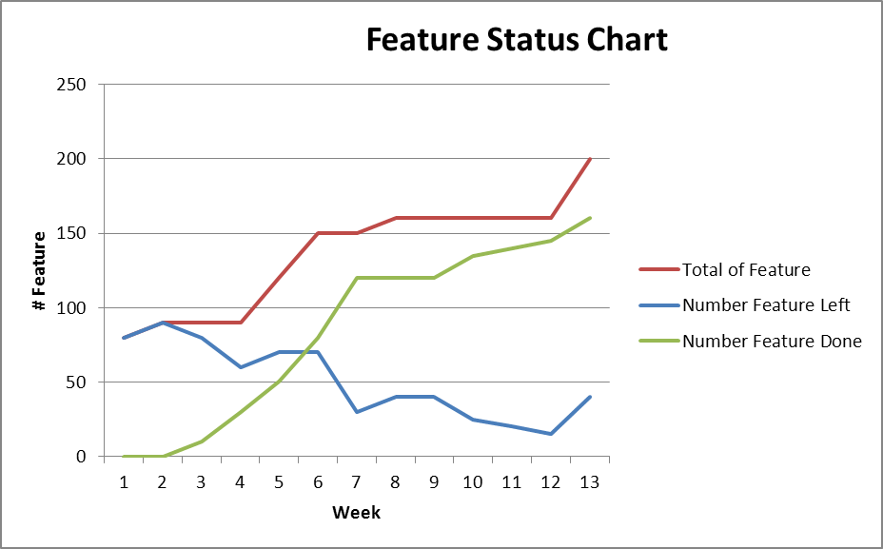

This chart will show total Feature that tem develop must implement. And then, it shows result of testing phase.

Data will be collected:

|  |  |  |  |
| --- | --- | --- | --- |
| **Data Collection** | **Purpose** | **Location** | **Periodic** |
| * # Total of Feature * # Number of Feature left * # Number of Feature Done | Compare and evaluate impact of current feature to project. | PM | Weekly |

* 1. **Testing Status :**

We are using this chart to report:

Data will be collected:

|  |  |  |  |
| --- | --- | --- | --- |
| **Data Collection** | **Purpose** | **Location** | **Periodic** |
| * # Total of Test Case * Standard for Testing | Compare and evaluate testing phase | PM, team leader Testing | Weekly |

* 1. **Risk Status :**

We are using this chart to report overview current defect status:

So, Data will be collected is:

|  |  |  |  |
| --- | --- | --- | --- |
| **Data Collection** | **Purpose** | **Location** | **Periodic** |
| * # risk for each Level * Impact and priority | Showing compare and evaluation impact of risk to project | PM, team leader Testing | Weekly |

1. **DASHBOARD :**

We are using summary chart to report. Reference to **Viking’s project Dashboard**